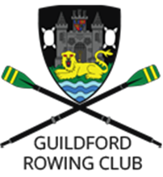
Guildford Rowing Club
The Boat House
Shalford Road,
Guildford, Surrey
GU1 3XL
Tel: 01483 565849
Chairman chairman@guildfordrowingclub.org.uk
Secretary secretary@guildfordrowingclub.org.uk
Captain captain@guildfordrowingclub.org.uk
Club Welfare Officer welfare@guildfordrowingclub.org.uk

Guildford Rowing Club Committee 2016-2017
Role | Name
Chairman | Paul Woowat
Secretary | Richard Warne
Club Captain | Rachel Spruce
Treasurer | Danny Skillman
Membership Secretary | Rachel Tasker
Vice-Captain Women | Jackie Johnson
Vice-Captain Junior | Ian Pigram
Vice-Captain Adaptive | Christopher Boys
Vice-Captain Men | Ben Hopwood
Fund Raising Coordinator | Carolyn Turner
Social Secretary | Olivia McGee
Marketing and Sponsorship | Mark Starling
Boatswain | John Redmond
Safety Advisor | Rachel Morris
Welfare Officer | Emily Rowland

